Group 51

LOGIC

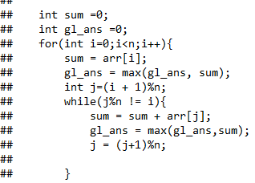

We basically initialized the sum variable to zero which will store the sum of the elements

We assume that let a subarray starts from the particular index, and then cycly adds the elements and get the maximum subarray sum.   
So basically we have to find that index from which subarray starts. First for loop starts the initializing the sum to arr[i], now we will loop in circle to find the maximum subarray sum. And in that process we are updating the global sum which is the actual maximum subarray6 sum.

This algorithm is O(n^2) algorithm .

So second “while loop” will loop to find the maximum subarray sum.

Sample Test Cases

